**DEMETRIA, CHRISTIAN JAY A.**

**IPT2 CASE STUDY DOCUMENTATION**

Initialize the local repository and cloning the repo.

Creating (switching) branch

Adding and committing the files and then pushing it inside the repository

**Header Part (HTML)**

**Introduction Section Update**

About and Quotes Section Added

Featured Photos Section Added

This draft is just the complete html file with no design or the CSS file.

CSS Code update up to the Home Section of the Portfolio

CSS Code Update on Quote Section and changes on some pictures for Featured Photos are made.

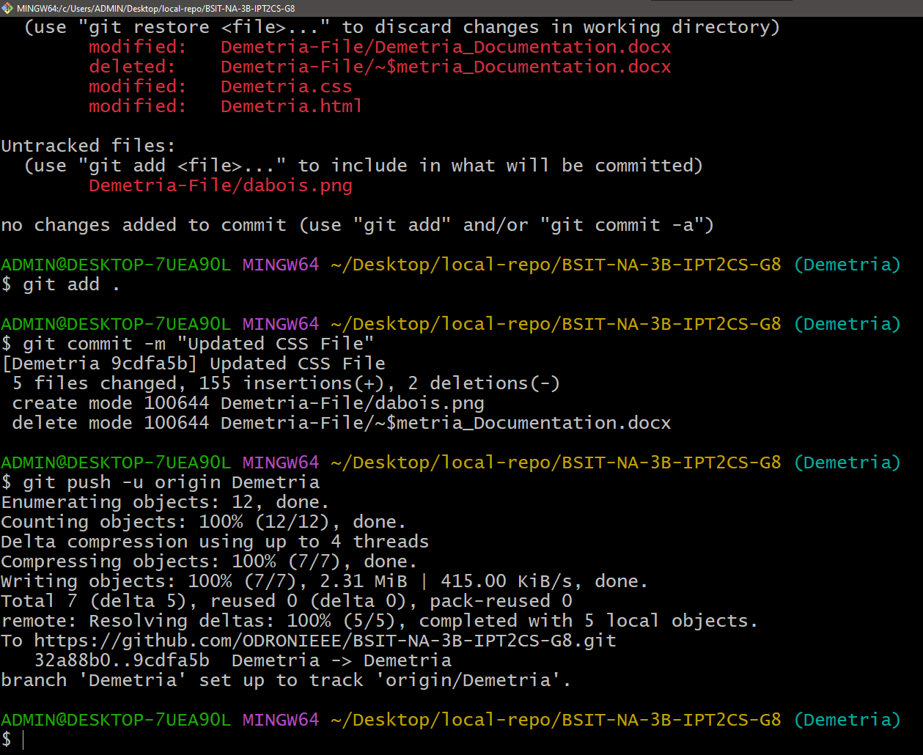

Revision of CSS File without js